Project Documentation

Project Title: Quizards
Date: 03/25/2026
Project Manager: Jayson
Project Team Members: Jayson Coleman, Jesse Wolford, Sean Reedy
Phase 2: Requirements Specification Document

Technique
We decided that observation would be the best way to find the requirements needed.

Findings
Through research, I found a flashcard app coded in C++ via this GitHub link: https://github.com/Samuelson777/Flashcard-Quiz-Application/blob/main/README.md?plain=1

Because this application will be done entirely in C++, the above link readme specifies what they need, such as a C++ and a minimum of C++11. I believe we should take a similar approach to this, as we can figure out from here our own requirements that fit our scope.

Prior to finding this application, other more popular apps such as Quizlet, used various languages to make their software and no visible sign of C++.

Functional Requirements
What we want with our software is to make flashcards from a file. Basically, we want users to create and generate their own flashcards for educational purposes. The software must allow the user to start with a start menu for the flashcard pool. It should always have an entry box placed after the question for the user to input their answer. The software should progress with the user through the set of flashcards they’ve created or premade flashcards. The software must allow the user to check their progress through the set of flashcards. Meaning when they get a wrong answer, it will remove the points from said score and vice versa for correct input. It must also allow the user to reset their quiz at any time.

Non-Functional Requirements
The page should run load in only a few seconds at maximum. The usability of the program must be easy for any user who uses it. The program should be secure via encryption and multi-factor authentication. The program should also be compatible with all types of operating systems.

Flowchart

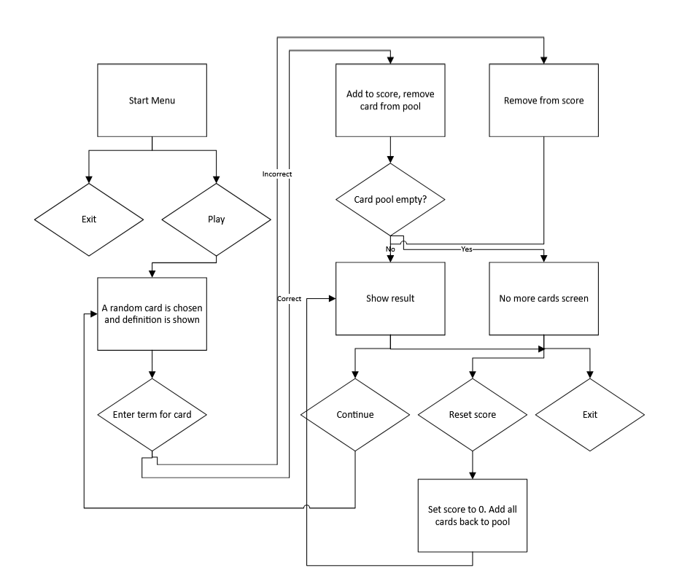Pseudocode

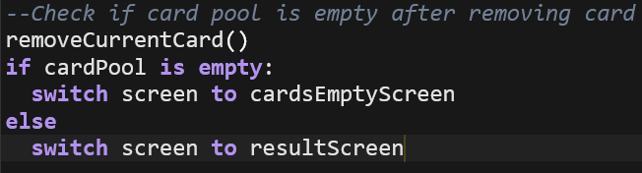UML Diagram

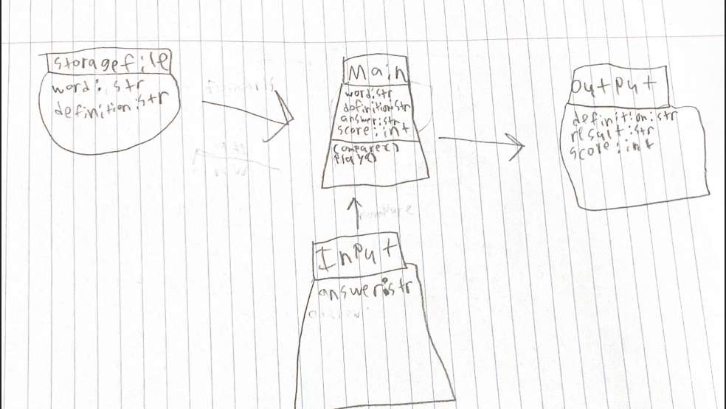

UI Wireframe

